AWS CLOUD

Getting Started with AWS
Getting Started Guide
Version 1.0

Table of Contents

Overview 3
Getting Started with AWS 5
Creating an AWS Account 5
Securing Your Account with IAM 6
Launching Your First EC2 Instance 7
Creating an S3 Bucket 8
Setting Up a Billing Alert 9
What’s Next? 10
Troubleshooting 11
FAQ’s 12

Overview
AWS (Amazon Web Services) is a cloud computing service that provides a variety of services, including computing power, storage, databases, networking, AI, ML, analytics, and more, over the internet. The service is provided on a pay-as-you-go basis.
With AWS, you can lease computing resources from a variety of secure data centers around the globe, scaling them up or down as needed. This is the foundation of cloud computing.
This guide helps you understand AWS Cloud and its core features.
Why Use AWS Cloud?
AWS lets you run your applications, store data, and deliver services entirely over the internet, with speed and reliability.
- No upfront hardware cost.
- Scale resource use based on demand.
- Access services remotely with an internet connection.
- Built-in security and compliance tools.
AWS groups its services into categories. The table below lists the most used services for beginners.
Category | Key Services and Purpose
Compute | EC2 (virtual servers), Lambda (serverless functions), Elastic Beanstalk (managed apps)
Storage | S3 (object storage), EBS (block storage), Glacier (long-term archiving)
Database | RDS (relational databases), DynamoDB (NoSQL), ElastiCache (in-memory cache)
Networking | VPC (private network), Route 53 (DNS), CloudFront (CDN)
Security | IAM (access control), AWS Shield (DDoS protection), AWS WAF (firewall)
Monitoring | CloudWatch (metrics and alerts), CloudTrail (activity logs)
Billing | Cost Explorer, AWS Budgets, Free Tier dashboard

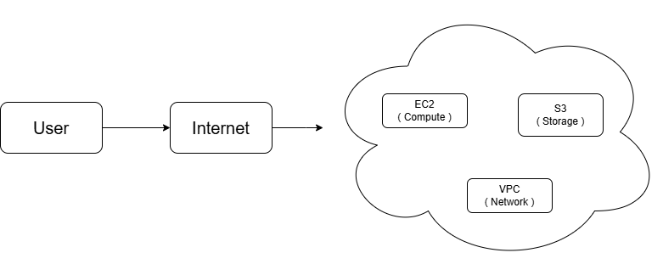
Fig 1: Basic AWS Architecture showing User access, compute, storage, and network services through the cloud.

Prerequisites
- Windows, macOS, or Linux with a modern web browser
- Stable broadband connection
- A valid email address
- Identity verification during account setup

Getting Started with AWS
This section lists everything you need before you begin, and walks you through creating your AWS account and making your first deployment.

Creating an AWS Account
Create your AWS account to access all AWS services.
To create an AWS account:
- Go to https://aws.amazon.com and click Create an AWS Account.
- On the AWS homepage, enter your email address and choose an AWS account name.
- Create a strong password and click Continue.
- On the contact information screen, select account type (Personal or Business), then enter your contact information.
- On the billing screen, enter your credit or debit card details.
Note: AWS does not charge unless you exceed Free Tier limits.
- Complete the identity verification.
- On Support Plan page, select the Basic Support plan (free) and click Complete Sign Up.
- Sign in to the AWS Management Console at https://console.aws.amazon.com.
Your AWS account is created. You can now access the AWS Management Console.

Securing Your Account with IAM
Your root account has full access to all AWS services. To secure your AWS account immediately after sign-up:

- In the AWS Console, search for IAM and open the IAM service.
- Go to Users and click Add Users.
- Enter a username and select AWS Management Console access.
- Attach the AdministratorAccess policy to the user.
- Download your credentials and sign out of the root account.
- Sign in as the IAM user.
Your IAM user is set up. Use this account for all daily AWS activities instead of the root account.

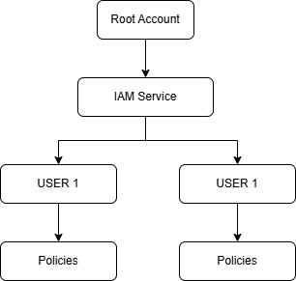
Fig 2: IAM Structure and policy access

Launching Your First EC2 Instance
EC2 lets you run virtual servers in the cloud.
To launch an EC2 instance:
- In the AWS Console, search for EC2 and click Launch Instance.
- In the Name field, enter a name, for example: my-first-server.
- Under Application and OS Images, select Amazon Linux 2023 (Free tier eligible).
- Under Instance type, select t2.micro (Free tier eligible).
- Under Key pair, click Create new key pair. Name it my-key and download the .pem file. Store it safely.
- Under Network settings, keep the default VPC and allow SSH traffic from your IP only.
- Click Launch Instance and select View all Instances.
- In the EC2 dashboard, wait until the Instance State shows Running.
Your EC2 instance is running. You can now connect to it using SSH.
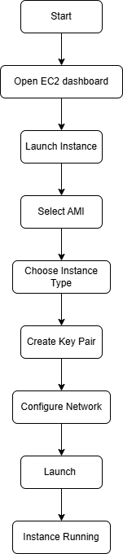
Fig 3: Workflow for launching an EC2 instance in AWS.

Creating an S3 Bucket
Amazon S3 stores files (called objects) in containers called buckets.
To create an S3 bucket:
- In the AWS Console, search for S3 and click Create bucket.
- Enter a unique bucket name.
Note: Bucket names must be globally unique across all AWS accounts.
- Select your preferred AWS Region.
- Keep Block all public access enabled.
- Click on Create bucket.
- Click your new bucket and use Upload to add files.
Your S3 bucket is created. You can now upload and manage files in it.

Setting Up a Billing Alert
Set up an alert to notify you when your usage is approaching the Free Tier limit.
To set up a billing alert:
- Go to the Billing Dashboard from the account menu (top right corner).
- Click Budgets in the left panel, then click Create a Budget.
- Select Cost budget and set a Monthly budget of USD 1.00.
- Add your email address to receive an alert when usage reaches 80% of the limit.
- Click Create budget.
Your billing alert is active. AWS sends you an email when usage reaches the threshold you set.

What’s Next?
After launching your first EC2 instance and creating an IAM user, you can continue exploring AWS services.
- Connect to your EC2 instance: Use SSH to access the server and run commands.
- Store files using Amazon S3: Create an S3 bucket to store application data, backups, or media files.
- Set up databases: Use Amazon RDS to deploy and manage relational databases.
- Monitor resources: Use Amazon CloudWatch to track performance and system metrics.
- Improve security: Configure IAM roles, security groups, and policies to control access.
- Manage costs: Use the AWS Billing Dashboard and set billing alerts.

Troubleshooting

Problem | Solution
Cannot sign in to the Console | Check that you are using the correct email and password. Use Forgot Password to reset if needed.
Credit card rejected during sign-up | Ensure the card is internationally enabled and has sufficient funds for a USD 1 pre-authorization check.
EC2 instance not starting | Check that you selected a Free Tier eligible instance type (t2.micro or t3.micro).
S3 bucket name already taken. | Bucket names are globally unique. Add numbers or your name to make it unique, for example: my-bucket-march2026.
Unexpected AWS charge on the card | Check your Billing Dashboard. Identify which service exceeded Free Tier limits and stop or delete it.
Cannot connect to EC2 via SSH | Verify that your Security Group allows inbound SSH (port 22) from your IP address only.

FAQs
- Is AWS the same as the internet?
No. AWS runs on the internet, but it is a separate platform. You use the internet to access AWS services.

- What is the root user?
The account owner's login was created during sign-up. It has full access to all services. Use it only for initial setup, then switch to an IAM user.

- Can multiple people share one AWS account?
Yes. Create separate IAM users for each person and assign only the permissions they need.

- Where can I see my current bill?
Go to the AWS Console > Billing and Cost Management > Bills. It shows a breakdown of charges by service and Region.

- What happens if I exceed the Free Tier?
AWS emails you when your usage approaches the Free Tier limits.

- Where is the official AWS documentation?
docs.aws.amazon.com. Every AWS service has a dedicated documentation page with guides, tutorials, and API references.

- How do I contact AWS Support?
In the AWS Console, click Support > Create case. The Basic Support plan (free) includes access to documentation and community forums.

